***Plus-one: adding one***

***Church-gale:  Good-Turing Estimation***

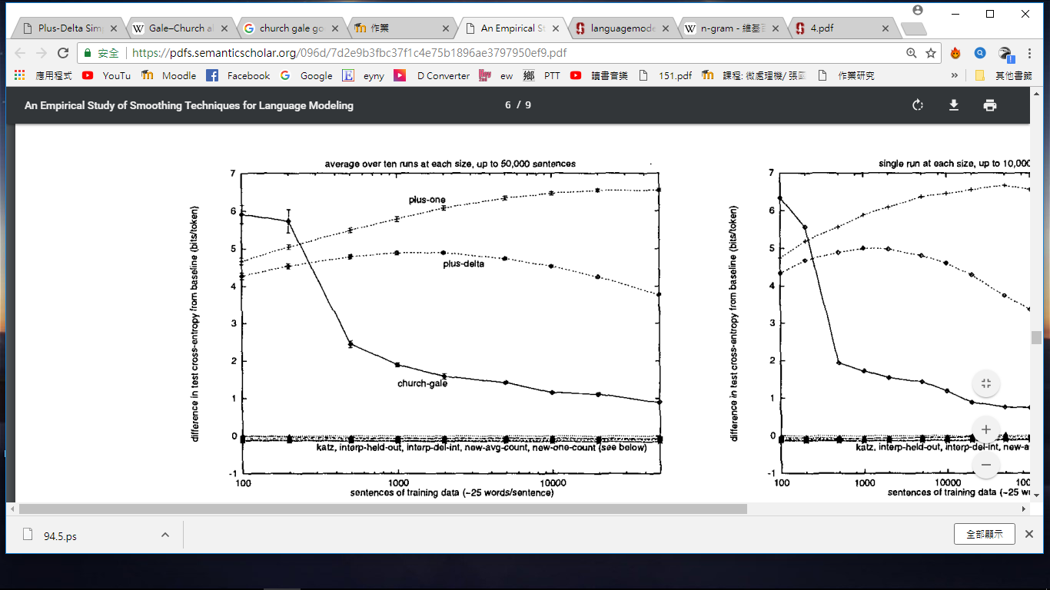

**分析:**

**add-one smoothing gives poor results because it assigns too much probability mass to unseen n-grams**

**Good-Turing thus requires elaboration to be useful. It forms a foundation**

**on which other smoothing methods build.**

**Bigram N=2,**

**Trigram N=3,**

**.......**

**當N越大，可靠性越低，運算成本越高，但辨識度越高**